RAG - Retrieval-Augmented Generation

The LLM retrieves certain info based on what the user has prompted.
The RAG framework follows the instruction, i.e., to retrieve relevant content first.
Then it combines the same with the user prompt and then generate a response.

- Retrieve relevant information
- Combine with user prompt
- Generate an output

It basically helps the model stay updated in terms of correctness or relevance of the facts based on which the responses are generated.

It is very much important for the retriever to be able to provide the LLM with the best quality data on which to ground its response.

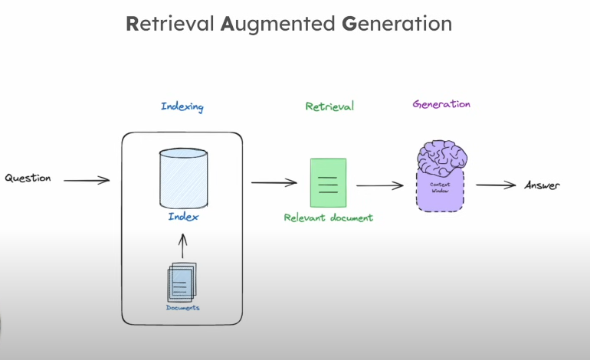

The key sources for relevant data might be PDF documents, images, an application, etc.
An aggregate of one or more sources are converted into vectors and stored in a vector database.

A vector database has a set of vectors that are the mathematical representation of structured and unstructured data.

These vectors are now the primary source of information for the LLM.
The prompt now transforms into prompt + retrieved data which is fed to the LLM which then produces the output to the question.
A challenge is to update the data source with relevant data so that each time when the database is queried, it gives facts of some positively valuable accuracy.

The vector database must be governed and managed properly for it to be a reliable source of data. If not it might lead to hallucination, perpetuating bias, etc.
The LLMs must be selected such that the data used to train them and their intellectual properties are known. If they are not very specific to the purpose of using it, then it might not produce reliable results.

RAG is in fact a way to eliminate hallucination

RAG makes a perfect fit where the source and information in the context of the prompt.

